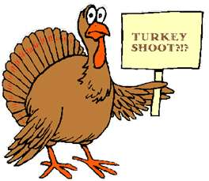 TURKEY SHOOT 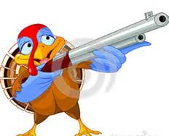

Franklin County Sportsmen’s Club, Inc.
In cooperation with the Deerfield Education and Conservation Corp.

Sundays: October 25 & November 1, 8, 15, & 22
9am – 12 noon

721 River Road, Deerfield, MA
6.7 miles from Rte 116
2.3 miles from Rtes 5 & 10

Prizes include:
TURKEYS, HAMS (not canned), & SAUSAGES (hot or sweet)

Young, Old and New Shooters are Welcome!!

EVENTS
100 yard Black Powder Rifle Shoot
100 yard Slug Shoot
Turkey Shoot
Rabbit Shoot

bad coffee, always free

****************** THIS EVENT IS OPEN TO THE PUBLIC ******************

